**Tab 1**

King James Audio Bible

Read as you were called

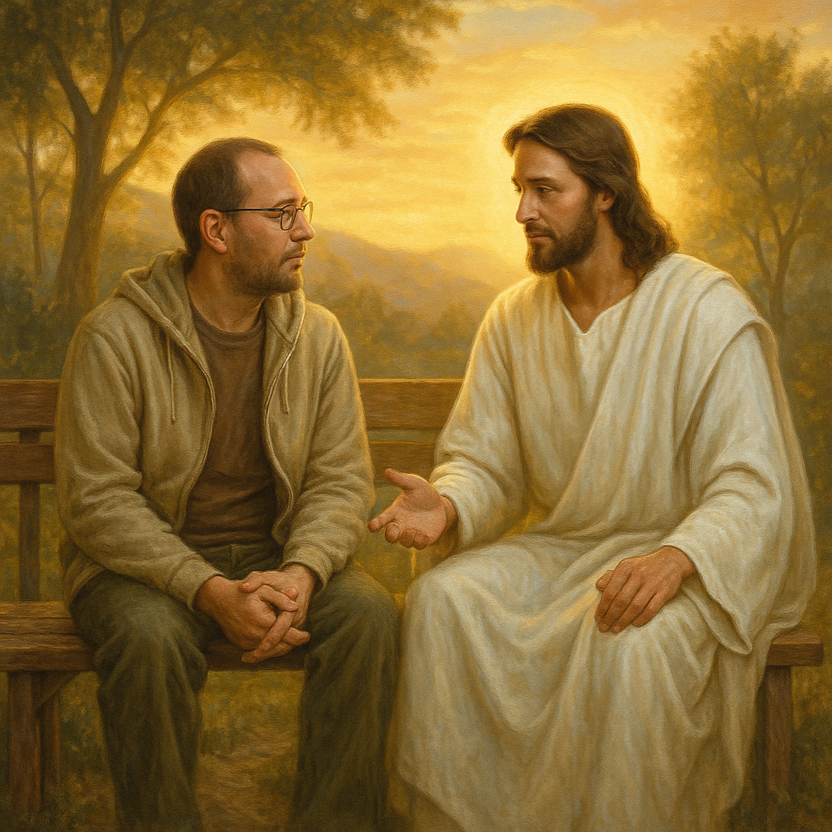

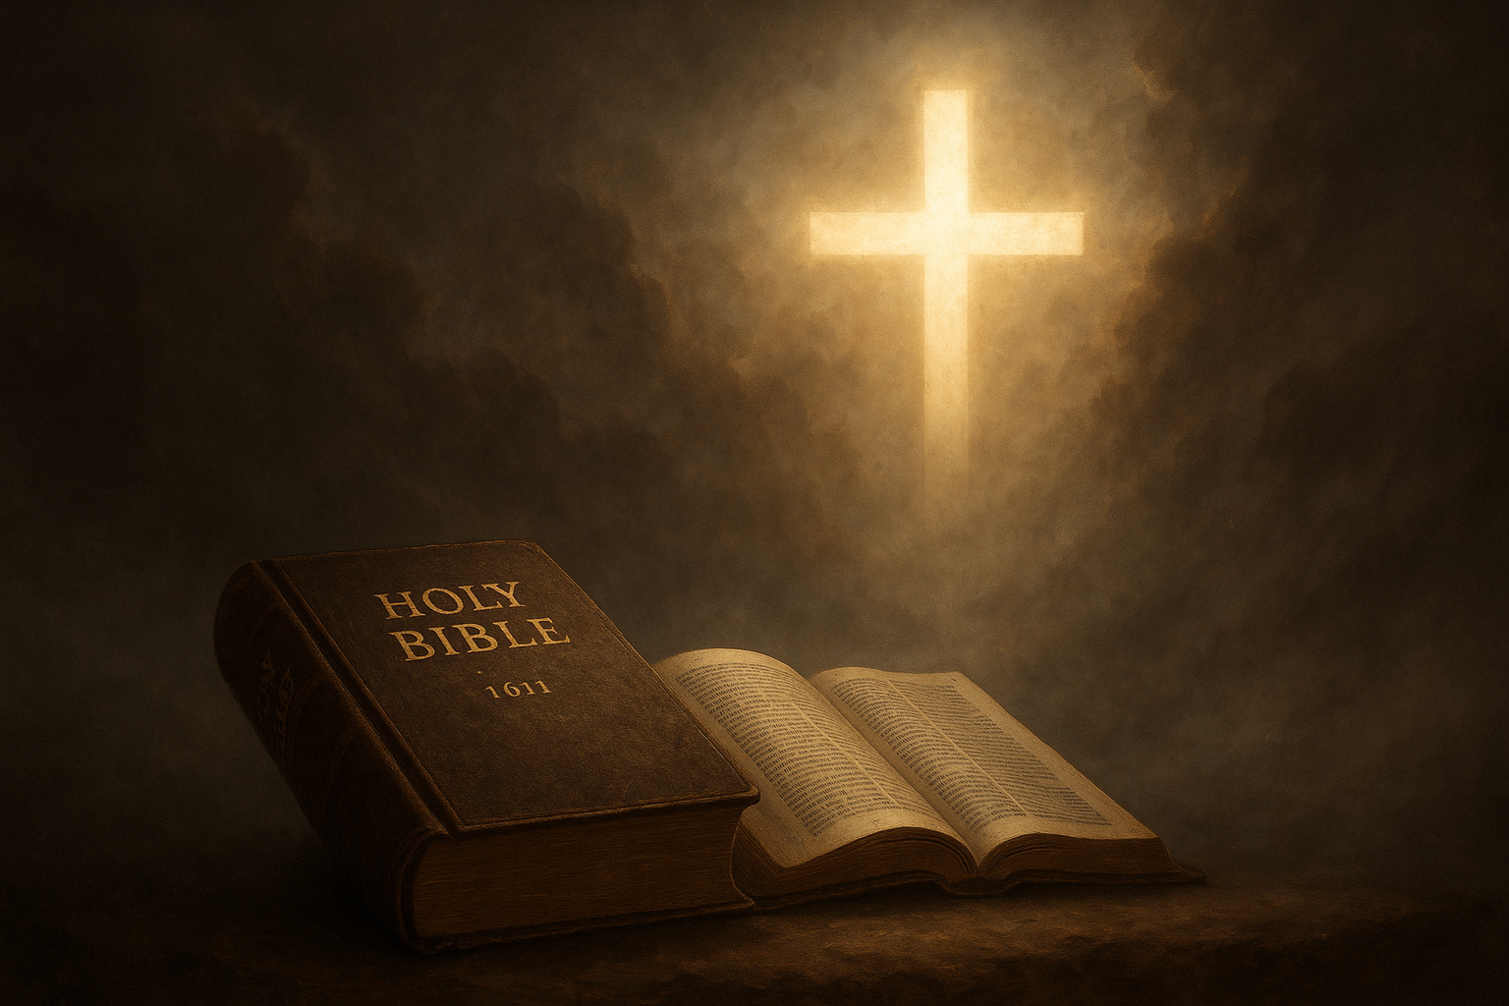

[Kjv.pdf](https://drive.google.com/file/d/1nnPmrpfszFkP-I4F4fIyMZUGPoi3U8k3/view?usp=drivesdk)

## **King James Version Table of Contents**

The King James Version (KJV) of the Bible includes a structured table of contents that allows readers to navigate through its books. Below is a simplified version of the KJV Table of Contents with links to each book.

### **Books of the Old Testament**

| **BOOK NUMBER** | **BOOK NAME** |
| --- | --- |
| 1 | [Genesis](https://drive.google.com/file/d/1Ydsg0IOUP6DbT0yjRV3Ih7PzCkt3eVDI/view?usp=drivesdk) |
| 2 | [Exodus](https://drive.google.com/file/d/1Ydsg0IOUP6DbT0yjRV3Ih7PzCkt3eVDI/view?usp=drivesdk) |
| 3 | [Leviticus](https://drive.google.com/file/d/1-9pdUDJZrCKoBtpSJo7WGvSf7gD_VCob/view?usp=drivesdk) |
| 4 | [Numbers](https://drive.google.com/file/d/135vy5zsNp1loNqroVSb0andH-DmiPtGv/view?usp=drivesdk) |
| 5 | [Deuteronomy](https://drive.google.com/file/d/1UabP3NZuWkL9vXG2vFlzvEeDRsaBDekt/view?usp=drivesdk) |
| 6 | [Deuteronomy](https://drive.google.com/file/d/1UabP3NZuWkL9vXG2vFlzvEeDRsaBDekt/view?usp=drivesdk) |
| 7 | [Judges](https://drive.google.com/file/d/1UabP3NZuWkL9vXG2vFlzvEeDRsaBDekt/view?usp=drivesdk) |
| 8 | [Ruth](https://drive.google.com/file/d/1QUts90IzmmZHuqsZI-muKDxAgsbbvw_1/view?usp=drivesdk) |
| 9 | [1 Samual](https://drive.google.com/file/d/1QUts90IzmmZHuqsZI-muKDxAgsbbvw_1/view?usp=drivesdk) |
| 10 | [2 Samnal](https://drive.google.com/file/d/1xifSdS3cPFpko3QgwpOUmOS91UQ5WxJ4/view?usp=drivesdk) |
| 11 | [1 Kings](https://drive.google.com/file/d/1UuKlCG1dVeX-bqs5biXix_Ps3XMxO3oS/view?usp=drivesdk) |
| 12 | [2 Kings](https://drive.google.com/file/d/1uLLWinJPjXkXl6RAWA_R1s288P1QbKXC/view?usp=drivesdk) |
| 13 | [1 Chronicles](https://drive.google.com/file/d/1FQGJDED7xU0sc7YLBU7Z6AedwpjtlUBZ/view?usp=drivesdk) |
| 14 | [2 Chronicles](https://drive.google.com/file/d/1nnPmrpfszFkP-I4F4fIyMZUGPoi3U8k3/view?usp=drivesdk) |
| 15 | [Ezra](https://drive.google.com/file/d/1TkAOW7Ba0bmbawymnrNxEXdwWxw9UcKz/view?usp=drivesdk) |
| 16 | [Nehmemiah](https://drive.google.com/file/d/1pqPkIQwcvkZiPQClr3Ko_jRjzzDtAwug/view?usp=drivesdk) |
| 17 | [Esther](https://drive.google.com/file/d/1cGKVXQVYFm89usipFD-KWQ03wPq4Ejsc/view?usp=drivesdk) |
| 18 | [Job](https://drive.google.com/file/d/1CPshjAiB5bcxOdD6cTTEkQ9h15WWup6N/view?usp=drivesdk) |
| 19 | [Psalms](https://drive.google.com/file/d/1LN5SUCsBMdVq-mC91SPdUfjv5QdveQHm/view?usp=drivesdk) |
| 20 | [Proverbs](https://drive.google.com/file/d/1F3teg-FB0BWmAmIRCLoBOLZqZ9PVEXUI/view?usp=drivesdk) |
| 21 | [Ecclesiastes](https://drive.google.com/file/d/1Hg-gGPkUXI2zu65OI8dM71dcjdnRutFx/view?usp=drivesdk) |
| 22 | [Song of Solomon](https://drive.google.com/file/d/1v2AmCLwrQ_qqPQwSRSqUN99RdcKHzaET/view?usp=drivesdk) |
| 23 | [Isaiah](https://drive.google.com/file/d/1v2AmCLwrQ_qqPQwSRSqUN99RdcKHzaET/view?usp=drivesdk) |
| 24 | [Jeremiah](https://drive.google.com/file/d/1zWzZIVaGDDC9mAvsI1cUrM8idx8zlpB-/view?usp=drivesdk) |
| 25 | [Lamentations](https://drive.google.com/file/d/1zWzZIVaGDDC9mAvsI1cUrM8idx8zlpB-/view?usp=drivesdk) |
| 26 | [Ezekiel](https://drive.google.com/file/d/1Q8Q_9-n2GQZXIJl5mwUe9eVkbLh1vLyC/view?usp=drivesdk) |
| 27 | [Daniel](https://drive.google.com/file/d/1RTVy8sMJ9kt08GipU-SO-xMVABJ5PMXD/view?usp=drivesdk) |
| 28 | [Hosea](https://drive.google.com/file/d/1B06Pioqm-AoE_TT2rKqSixBEvFYclz4J/view?usp=drivesdk) |
| 29 | [Joel](https://drive.google.com/file/d/1xmz28rEVZFW4pUFePjmsJ_1yNtL_klS8/view?usp=drivesdk) |
| 30 | [Hosea](https://drive.google.com/file/d/1B06Pioqm-AoE_TT2rKqSixBEvFYclz4J/view?usp=drivesdk) |
| 31 | [Obadiah](https://drive.google.com/file/d/1LvPpqgURCJGmNP_RaR135Vqyhe7wzvN5/view?usp=drivesdk) |
| 32 | [Jonah](https://drive.google.com/file/d/1nLHkJ8auNRA15evUC1AHkPodnL3fr2qP/view?usp=drivesdk) |
| 33 | [Micah](https://drive.google.com/file/d/1UqJEQCctVec-HaoW5H3_e06UI70zD-Re/view?usp=drivesdk) |
| 34 | [Nahum](https://drive.google.com/file/d/1qXE1DtK6w2iKTH0DDmccM_rdqhwyGAC1/view?usp=drivesdk) |
| 35 | [Habakkuk](https://drive.google.com/file/d/1A5PESEYhP75Vfv_fDU_7NTTLptFSVT3I/view?usp=drivesdk) |
| 36 | [Zephaniah](https://drive.google.com/file/d/14rv3oUsdIjXANIxzwe8_agzT3hB6ZB78/view?usp=drivesdk) |
| 37 | [Haggai](https://drive.google.com/file/d/1wSKig-1UIPYfRvFOJRnB1sB5_yGVAq_L/view?usp=drivesdk) |
| 38 | [Zechariah](https://drive.google.com/file/d/14rv3oUsdIjXANIxzwe8_agzT3hB6ZB78/view?usp=drivesdk) |
| 39 | [Malachi](https://drive.google.com/file/d/1_O-5IbOzjpqi52Cjds6s5YTtkG96UqRG/view?usp=drivesdk) |

### **Books of the New Testament**

| **BOOK NUMBER** | **BOOK NAME** |
| --- | --- |
| 1 | [Matthew](https://drive.google.com/file/d/1ytBC7caykay1eyBUwvHR48OfBs4m3551/view?usp=drivesdk) |
| 2 | [Mark](https://drive.google.com/file/d/13QdxLOwMedwHZsrx6UF1Y-7H5SkCSb0j/view?usp=drivesdk) |
| 3 | [Luke](https://drive.google.com/file/d/1FT1giibE6bg6HRSlyP7KK5fP4CQWbujn/view?usp=drivesdk) |
| 4 | [John](https://drive.google.com/file/d/165Wwgn6jJcBgKtY5CFz7euFzn2pfDf9J/view?usp=drivesdk) |
| 5[Acts](https://drive.google.com/file/d/1PICGjszRx5c3v5febCFe2iW3MoaIOn2N/view?usp=drivesdk) | [Acts](https://drive.google.com/file/d/1PICGjszRx5c3v5febCFe2iW3MoaIOn2N/view?usp=drivesdk) |
| 6 | [Romans](https://drive.google.com/file/d/1OfJGiqbmFNGJ5rc8Ur5Uc8vfEgEnNUrX/view?usp=drivesdk) |
| 7 | [1 Corinthians](https://drive.google.com/file/d/1WpDf7McH71VNyn8YJUhGbFWQdPsk_kXJ/view?usp=drivesdk) |
| 8 | [2 Corinthians](https://drive.google.com/file/d/1WpDf7McH71VNyn8YJUhGbFWQdPsk_kXJ/view?usp=drivesdk) |
| 9 | [Galatians](https://drive.google.com/file/d/1WpDf7McH71VNyn8YJUhGbFWQdPsk_kXJ/view?usp=drivesdk) |
| 10 | [Ephesians](https://drive.google.com/file/d/1K1b2R0bozuX6mZfSkt4UqYtFlCaqLHon/view?usp=drivesdk) |
| 11 | [Philippians](https://drive.google.com/file/d/1xHiQc4ndBP-hVRLreuZ-EkWTECYO7tmg/view?usp=drivesdk) |
| 12 | [Colossians](https://drive.google.com/file/d/1ZYkPdu_OEhHEsG8sx-Vx9rpOm5IFIesQ/view?usp=drivesdk) |
| 13 | [1 Thessalonians](https://drive.google.com/file/d/1Q3BW1kh3W0LICZw8gbCOWF7uYhWCSVYZ/view?usp=drivesdk) |
| 14 | [2 Thessalonians](https://drive.google.com/file/d/1kQERr75L70wnsIsCJkGCsW0n-s4NNOmF/view?usp=drivesdk) |
| 15 | [1 Timothy](https://drive.google.com/file/d/1kQERr75L70wnsIsCJkGCsW0n-s4NNOmF/view?usp=drivesdk) |
| 16 | [2 Timothy](https://drive.google.com/file/d/1OTdQ4VvPC6ltcksyl2O6WelHS7Fu6eeG/view?usp=drivesdk) |
| 17 | [Titus](https://drive.google.com/file/d/1i_7SdDzDlnqT65HFGnA917u4qLjPYBHP/view?usp=drivesdk) |
| 18 | [Philemon](https://drive.google.com/file/d/16aX6z98a1lHuXR6jA_M8yjoiq3maupKe/view?usp=drivesdk) |
| 19 | [Hebrews](https://drive.google.com/file/d/1W8iJcLdK-ziVws77OYJwrNbw3fYq_KXH/view?usp=drivesdk) |
| 20 | [James](https://drive.google.com/file/d/1sgJDr1_EpH2t0-cCIHxnP_FURLUtUzZG/view?usp=drivesdk) |
| 21 | 1 [Peter](https://drive.google.com/file/d/1e5VRIsibysjoM7UoJIp_oQh8n0xvAoay/view?usp=drivesdk) |
| 22 | [2 Peter](https://drive.google.com/file/d/1pwIqGA_pQuvi1NeSAiTe4KmpjkMYC8WL/view?usp=drivesdk) |
| 23 | [1 John](https://drive.google.com/file/d/1FKjzIsGHMh9Nd81VgL7RPCUgcWznpLE3/view?usp=drivesdk) |
| 24 | [2 John](https://drive.google.com/file/d/1pwIqGA_pQuvi1NeSAiTe4KmpjkMYC8WL/view?usp=drivesdk) |
| 25 | [3 John](https://drive.google.com/file/d/15p8C_XbU08d_-lrQXbMcJPbdLk91L7Bi/view?usp=drivesdk) |
| 26 | [Jude](https://drive.google.com/file/d/1pwIqGA_pQuvi1NeSAiTe4KmpjkMYC8WL/view?usp=drivesdk) |
| 27 | [Revelation](https://drive.google.com/file/d/1x0Wsv8RUUw8_DSbKwqK_tXEZsiekF42V/view?usp=drivesdk) |